OTC Flow

- SALES ORDER

Company Code: 4700
Sales Document type: ZOR
Sales Area: 4700/10/10

Screen Shot 1:

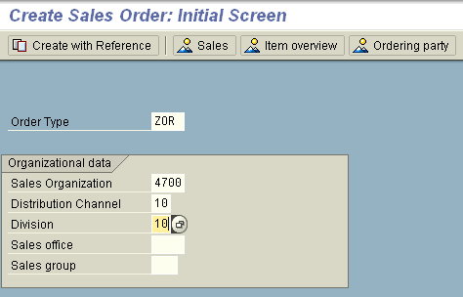

Click Enter

Step 2:

Header Level:

- Enter Sold to party: 1000991
- Enter Ship to party: 1000991
- Enter PO Number: Test
- Enter Payment term: 0001

Item Level:

- Enter Materials in Item Level: 1000309
- Enter order Qty: 1
- Enter Plant: 4702
- Click Enter:

Refer Screen Shot:

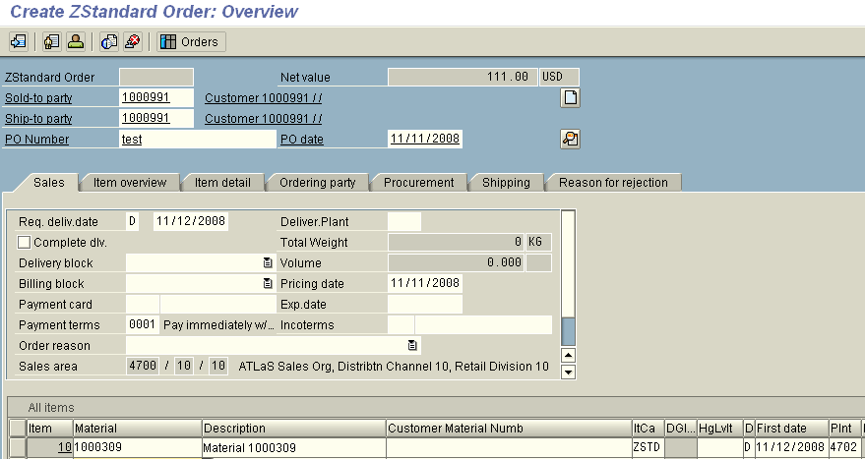

Go to→ Item→Billing

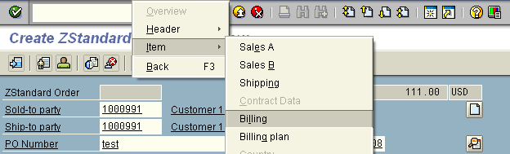

Enter the INCO Terms in the Item Levels: CFR (COST AND FREIGHT)
Click Save

- DELIVERY

Delivery Document type: ZLF

T – Code VL01N

- Enter Shipping Point: 4702
- Enter Sales document number:
- Note: Enter Delivery date: (Delivery date should be taken from Schedule lines in Sales order) Refer Screen Shot below:

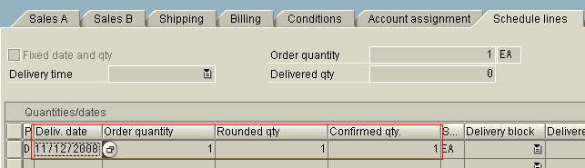

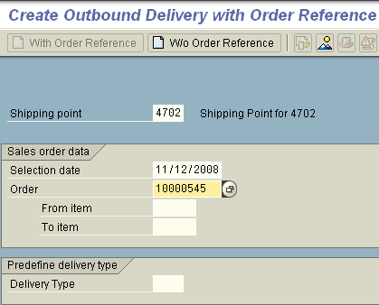

Click Enter

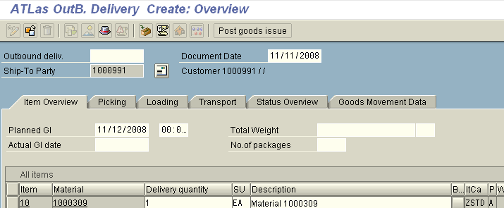

Enter Picking Qty & Storage Location:

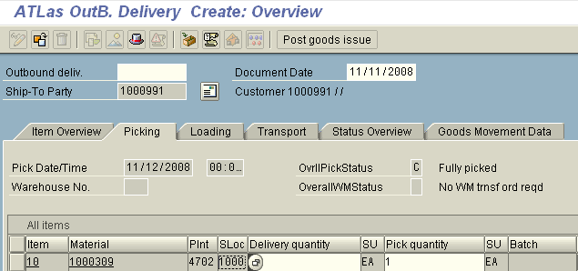

Click on Post Goods Issue:

- BILLING

Billing Document type: F2

T – Code – VF01

Enter Delivery Document number:

Refer Screen Shot Below:

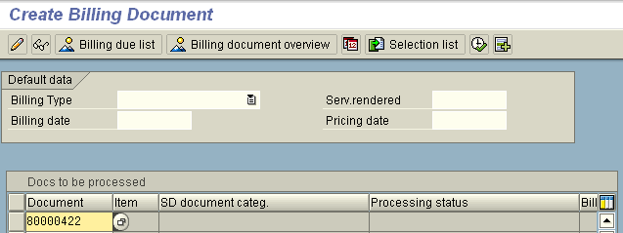

Click Enter

Refer Screen Shot below:

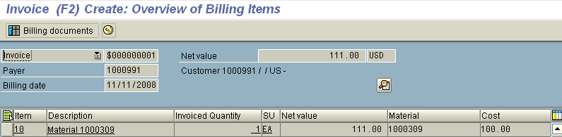

Click Save

Billing Document should be created (Refer Screen Shot below)

Display the Billing document: T – Code – VF03

Enter the Billing Document number from the above Screen shot:

Click on Accounting Document tab:

Refer the Screen Shot:

